

Practices for Secure Software Report

Table of Contents
Document Revision History 3
Client 3
Instructions 3
Developer 4
1. Algorithm Cipher 4
2. Certificate Generation 4
3. Deploy Cipher 4
4. Secure Communications 4
5. Secondary Testing 4
6. Functional Testing 4
7. Summary 4
8. Industry Standard Best Practices 4

Document Revision History

Version | Date | Author | Comments
1.0 | 10/14/2026 | Kelelah

Client



Instructions

Submit this completed practices for secure software report. Replace the bracketed text with the relevant information. You must document your process for writing secure communications and refactoring code that complies with software security testing protocols.

- Respond to the steps outlined below and include your findings.
- Respond using your own words. You may also choose to include images or supporting materials. If you include them, make certain to insert them in all the relevant locations in the document.
- Refer to the Project Two Guidelines and Rubric for more detailed instructions about each section of the template.

Developer
Kelelah Tome

Algorithm Cipher

As a developer for Global Rain, I recommend that Artemis Financial use the Advanced Encryption Standard (AES) with a 256-bit key and Galois/Counter Mode (GCM) when application-level encryption is needed. Artemis Financial provides financial consulting services involving savings, retirement, investments, and insurance. Because the company handles sensitive customer information, it must protect the confidentiality and integrity of financial records and communications. Implementing appropriate encryption and secure communication protocols can help reduce the risk of unauthorized access and data tampering.
AES is a symmetric encryption algorithm, meaning that the same secret key is used to encrypt and decrypt information. Oracle (2017) identifies AES as a standard cipher algorithm supported by Java security APIs and documents its 128-bit, 192-bit, and 256-bit key lengths. AES is widely used because it provides strong encryption and efficiently processes information.
AES-256-GCM is a suitable choice because GCM provides authenticated encryption. This means it helps protect information from being read by unauthorized individuals while also allowing the application to detect modifications to encrypted data. This protection is important for Artemis Financial because unauthorized changes to financial information could affect the accuracy and reliability of customer records.
Manico and Detlefsen (2014) discuss protecting sensitive information both in transit and at rest, emphasizing the importance of using appropriate security mechanisms when designing Java web applications. Applying these principles to Artemis Financial means that Global Rain should consider how information is protected while being transmitted over a network and while stored in databases or files.
Artemis Financial also requires a file verification feature. For this requirement, I recommend using the Secure Hash Algorithm 256 (SHA-256) to generate a message digest for transferred files. Oracle (2017) lists SHA-256 among the standard message-digest algorithms recognized by Java. The application can calculate a digest for a file and compare it with a trusted digest to help determine whether the file's contents have changed.
AES and SHA-256 perform different security functions. AES encrypts data to protect confidentiality, while SHA-256 produces a fixed-length digest to help verify integrity. A checksum alone does not prove the identity of the sender or prevent an attacker from replacing both the file and its checksum. Therefore, Artemis Financial should obtain expected digests through a trusted channel and use appropriate authentication mechanisms when protection against deliberate tampering is required.
The application should also use HTTPS with a modern version of Transport Layer Security (TLS). Manico and Detlefsen (2014) address secure data transmission, protocol versions, cipher suites, and certificate verification as important aspects of protecting sensitive information in Java applications. Applying these practices will help Artemis Financial establish secure connections between customers and its web server.
Hash Functions and Bit Levels
A cryptographic hash function processes input data and generates a fixed-length output called a hash or message digest. SHA-256 belongs to the SHA-2 family and produces a 256-bit digest, usually represented as 64 hexadecimal characters. The output length remains the same regardless of whether the input is a small text document or a large file.
For example, Artemis Financial could calculate the SHA-256 digest of a document before transferring it. After the document reaches its destination, the application could calculate another digest and compare the two values. If the digests match, the comparison provides evidence that the file contents are identical, provided that the expected digest is trustworthy. If the values differ, the application should treat the file as potentially altered or corrupted and investigate before accepting it.
Oracle (2017) documents SHA-256 as a standard message-digest algorithm name in Java. This supports the use of established Java security APIs instead of developing a custom hashing algorithm. Using standard cryptographic functionality helps reduce implementation errors and makes the application easier to maintain.
AES uses a different bit structure from SHA-256. According to Oracle (2017), AES supports key lengths of 128, 192, and 256 bits. AES uses a 128-bit block size regardless of the selected key length. AES-256 uses a 256-bit secret key and performs 14 encryption rounds. Its large key space makes exhaustive brute-force attacks impractical with currently known conventional computing methods, assuming correct implementation and secure key management.
It is important to distinguish the length of an encryption key from the length of a hash digest. AES-256 uses a 256-bit secret key, whereas SHA-256 produces a 256-bit digest. A hash digest is not an encryption key, and hashing is not reversible encryption.
Manico and Detlefsen (2014) discuss encryption and signing as separate security functions. This distinction is important for Artemis Financial because calculating a checksum and authenticating a sender are different requirements. A plain SHA-256 digest can help identify changes in file contents, but it does not independently establish who created the file. For stronger protection, the application could use a digital signature or a keyed message authentication code when appropriate. AES-GCM can also authenticate encrypted data, provided that the encryption keys and nonces are handled correctly.
Random Numbers and Symmetric Versus Asymmetric Keys
Secure cryptography requires more than choosing an appropriate algorithm. Developers must also generate unpredictable cryptographic values, protect keys, and implement encryption correctly. Oracle (2017) documents standard Java security algorithm names, including algorithms used for secure random-number generation. Java's SecureRandom functionality can generate unpredictable values for cryptographic operations.
Artemis Financial should use a cryptographically secure random-number generator when creating encryption keys and other values that require unpredictability. Developers should not use predictable information, such as a customer's name, a birth date, or a simple number sequence, as an encryption key. Predictable keys make it easier for attackers to guess the values needed to access protected information.
AES is a symmetric encryption algorithm. It uses the same secret key for encryption and decryption. Symmetric encryption is efficient and appropriate for protecting large amounts of information, including financial documents and application data. However, the secret key must be securely shared or made available to authorized parties. If an attacker obtains the key, the attacker may be able to decrypt information protected by that key.
Asymmetric cryptography uses a pair of mathematically related keys: a public key and a private key. The public key can generally be distributed, while the private key must remain protected. Oracle (2017) identifies RSA as a standard algorithm name recognized by Java security APIs. RSA can support public-key encryption and digital signatures, depending on the operation and configuration.
Manico and Detlefsen (2014) discuss symmetric and asymmetric cryptography, encryption and decryption, signing and verification, and certificate and key management. These concepts demonstrate why a secure application must consider how cryptographic keys are generated, distributed, stored, and used. A strong algorithm cannot protect information if its private or secret keys are exposed.
Symmetric and asymmetric cryptography commonly work together. For example, TLS uses appropriate public-key mechanisms for authentication and key establishment, then uses symmetric encryption to protect application traffic efficiently. Artemis Financial should use a properly configured TLS implementation instead of creating its own cryptographic protocol.
When AES-GCM is used, developers must ensure that a nonce is never reused with the same encryption key. A nonce is a value required by the encryption mode; it is not a secret key. Reusing a nonce with the same AES-GCM key can seriously weaken confidentiality and authentication. The application must also protect secret keys from unauthorized access and follow appropriate key-storage, access-control, and rotation procedures.
These practices would help Global Rain protect Artemis Financial's customer information by reducing the likelihood of predictable cryptographic values, exposed keys, and insecure communication configurations.
History and Current State of Encryption Algorithms
Encryption algorithms have evolved as computing capabilities have increased and researchers have discovered weaknesses in older cryptographic methods. Algorithms that were once widely used may no longer provide sufficient protection for modern applications.
The Data Encryption Standard (DES) was historically used to protect information, but its 56-bit effective key length makes it unsuitable for new applications that require strong protection against brute-force attacks. Triple DES, also known as 3DES or DESede, was developed to improve on DES by applying its operations multiple times. However, Triple DES is also an outdated choice for new general-purpose encryption systems.
AES was adopted by the National Institute of Standards and Technology (NIST) in 2001 as a modern encryption standard. It supports 128-bit, 192-bit, and 256-bit keys and remains widely used in contemporary security systems. Its security properties and efficiency make AES an appropriate choice for protecting Artemis Financial's sensitive information.
Hashing algorithms have also evolved. MD5 and SHA-1 were widely used in older applications, but known collision weaknesses make them unsuitable for new security-sensitive applications that depend on collision resistance. A collision occurs when two different inputs produce the same digest. SHA-256 is a more appropriate option for new file-integrity verification features.
Oracle (2017) lists multiple encryption algorithms, digest algorithms, and other cryptographic services supported by Java. However, an algorithm's appearance in the documentation does not automatically mean that it is suitable for every new application. Developers must consider the algorithm's intended purpose, current security recommendations, and the configuration in which it will be used.
Manico and Detlefsen (2014) emphasize several broader areas of Java application security, including protecting data in transit, managing certificates and keys, and using secure random numbers. These considerations remain important because selecting a strong algorithm is only one part of building secure software. Developers must also configure the application correctly, protect cryptographic keys, validate security certificates, and test the implementation.
For Artemis Financial, Global Rain should use AES-256-GCM where application-level authenticated encryption is required, SHA-256 for the required checksum functionality, and modern TLS to protect network communications. The development team should also avoid outdated cryptographic algorithms, use established Java security APIs, manage keys securely, and test the application to verify that its security requirements have been met.
In conclusion, AES-256-GCM, SHA-256, and modern TLS provide complementary security functions for Artemis Financial. AES-GCM helps protect confidentiality and authenticate encrypted data, SHA-256 generates digests for file-integrity comparisons, and TLS protects communications between clients and the web server. By combining these mechanisms with secure random-number generation, appropriate key management, and thorough testing, Global Rain can help Artemis Financial protect customer financial information and improve the security of its web application.

References

Manico, J., & Detlefsen, A. (2014). Iron-clad Java: Building secure web applications. McGraw-Hill Education. https://learning.oreilly.com/library/view/iron-clad-java/9780071835886/

Oracle. (2017). Java security standard algorithm names. Java Platform, Standard Edition 9. https://docs.oracle.com/javase/9/docs/specs/security/standard-names.html#cipher-algorithm-names

Certificate Generation

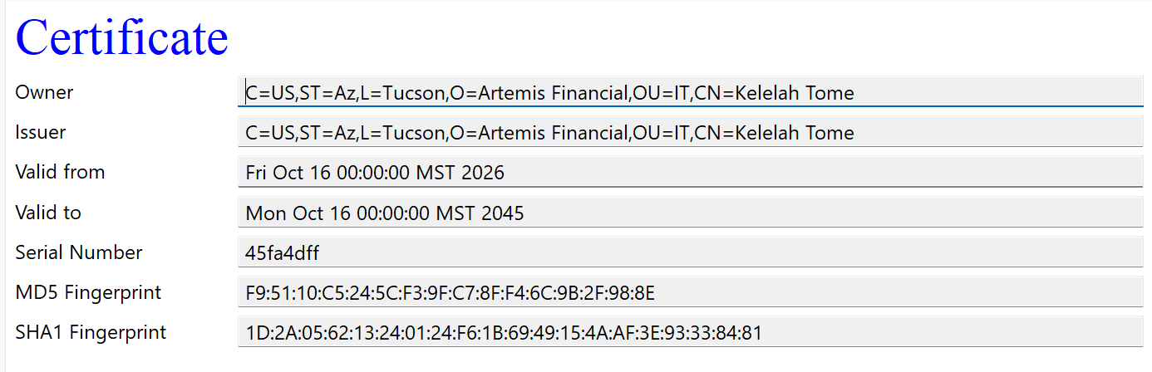

Figure 1a: Details of the self-signed certificate generated via Java Keytool, displaying organizational identity and cryptographic fingerprints.

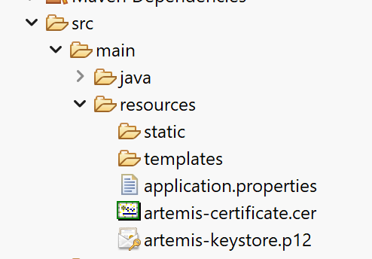

Figure 1b: Project resource dictionary showing the exported artemis-certificate.cer file and artemis-keystore.p12 keystore.

Deploy Cipher

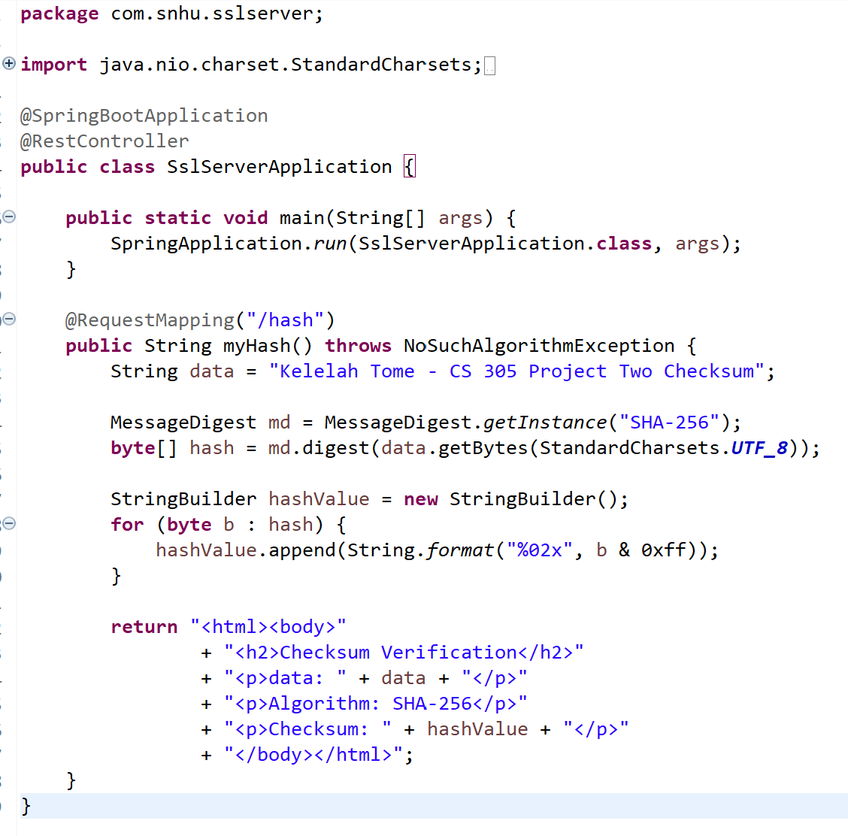

Figure 2: Refactored SslServerApplication.java implementing the SHA-256 hashing algorithm and unique data string.

Secure Communications

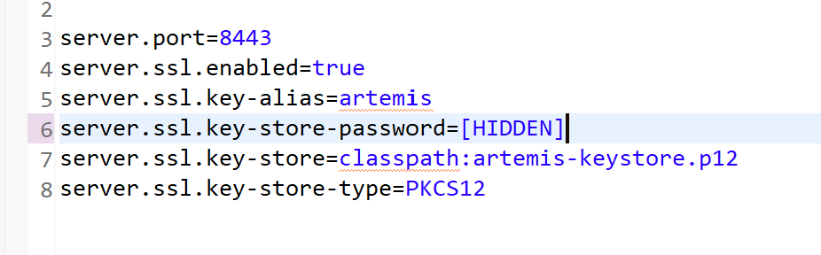

Figure 3a: application.properties configuration mapping port 8443, enabling SSL, and referencing the PKCS12 keystore.

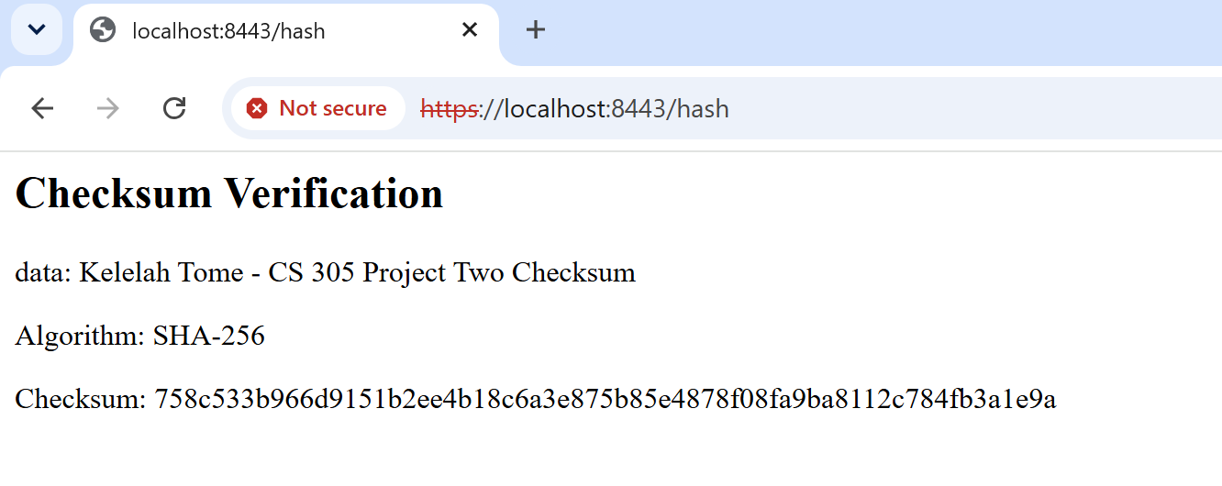

Figure 3b: Web browser output demonstrating successful HTTPS connection and SHA-256 checksum generation on port 8443.

Secondary Testing
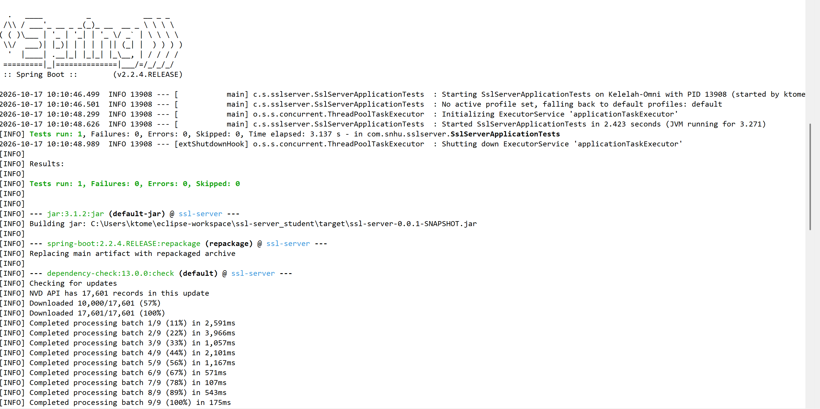

Figure 4a: Console execution log showing successful Spring Boot application startup and OWASP Dependency-Check scan execution.

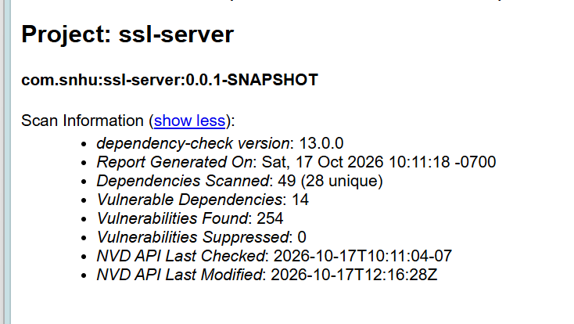

Figure 4b: Summary report generated by the OWASP Dependency-Check tool identifying project dependencies

Functional Testing

Figure 5a: Refactored Java code using MessageDigest with UTF-8 byte conversion to generate the SHA-256 checksum.

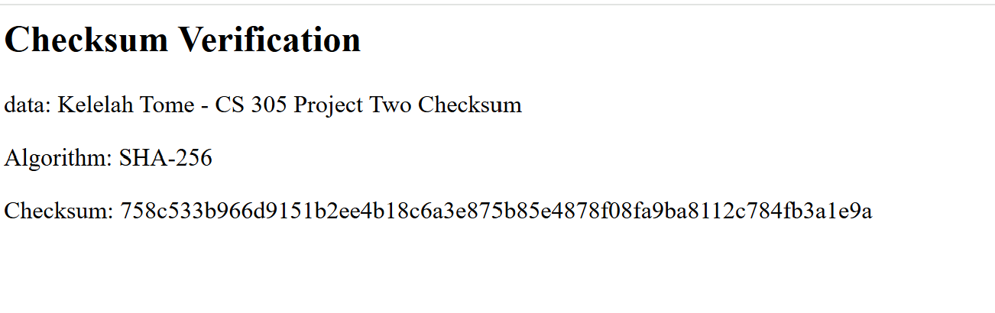
Figure 5b: Functional web endpoint rendering the formatted checksum, algorithm name, and data string

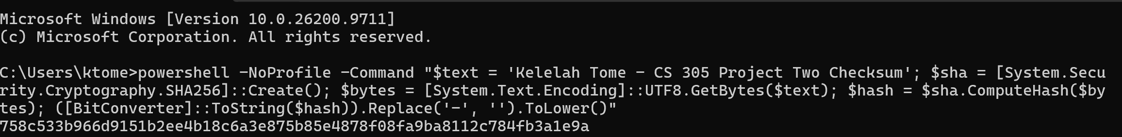

Figure 5c: Independent checksum verification executed in PowerShell confirming exact match with application output.

Summary

During this project, I refactored the Artemis Financial application to improve the security and reliability of its checksum verification functionally. I implemented the SHA-256 hashing algorithm using Java’s MessageDigest class to generate a checksum for the data string “Kelelah Tome – CS 305 Project Two Checksum.” I also used UTF-8 encoding to ensure that the input data is converted into bytes consistently before hashing. The application converts the resulting hash into hexadecimal strings and displays the original data, hashing algorithm, and checksum on the /hash endpoint.
The Vulnerability Assessment Process Flow diagram identifies several areas to review, including cryptography, client/server communication, code quality, secure coding practices, and code review. My refactoring primarily addressed the cryptography and client/server areas. I used SHA-256 to generate a checksum that can help verify data integrity when compared with a trusted checksum. I also configured the application to use HTTPS on port 8443 and created a PKCS12 keystore containing a private key and certificate. HTTPS helps protect information transmitted between the browser and the server. I reviewed the code changes and tested the application to confirm that the checksum endpoint continued to work as expected.
I followed security testing practices by opening https://localhost:8443/hash in a browser and confirming that the page displayed the expected data, algorithm, and checksum. I independently calculated the SHA-256 checksum using PowerShell and verified that it matched the application’s output. I also ran OWASP Dependency-Check to examine third-party libraries for known vulnerabilities. The scan completed and generated an HTML report, but it identified vulnerabilities in existing dependencies. These findings must be reviewed and addressed where appropriate, followed by another scan to evaluate the results. A successful build and matching checksum demonstrate that the application is functioning for the tests performed, but they do not prove that all security vulnerabilities have been eliminated.
I added layers of security by combining cryptographic hashing, HTTPS communication, and dependency scanning with functional testing and code review. Each layer serves a different purpose: SHA-256 supports data integrity verification, HTTPS helps protect data in transit, and dependency scanning helps identify potential risks in third-party components. Reviewing the code and retesting after changes helps confirm that security improvements do not break existing functionality. Together, these practices provide a structured approach to improving the application’s security while identifying areas that may require further remediation.

Industry Standard Best Practices

I applied industry standard secure coding practices by using SHA-256 for checksum generation, configuring HTTPS, and testing the application after making changes. SHA-256 is a widely used cryptographic hash algorithm that produces a fixed-length hash value from input data. Comparing the checksum generated by the application with an independently calculated checksum helped verify that the hashing implementation worked correctly for the selected input.
I maintained the application’s existing security by testing the /hash endpoint after configuring the server for HTTPS and confirming that the application continued to return the expected results. I used a PKCS12 keystore containing a private key and certificate to configure the HTTPS connection. I also ran OWASP Dependency-Check to examine the project’s dependencies for known vulnerabilities. The scan completed successfully and produced an HTML report, although the report identified vulnerabilities in several dependencies. These findings should be reviewed to determine which libraries need updates or other remediation. A successful scan does not mean that the dependencies are free of vulnerabilities.
Applying secure coding best practices benefits Artemis Financial by helping protect sensitive information, support data integrity, and reduce the risk security incidents. HTTPS helps protect information while it travels between the browser and server, while checksum verification helps detect changes to data when the checksum is obtained and compared through a trusted process. Dependency scanning helps the organization identify risks that could lead to incidents. Regular testings, timely dependency updates, and continued security reviews can reduce the likelihood of service disruptions, data exposure, and costly remediation. These practices also help the company maintain customer trust and demonstrate a commitment to protecting its software and information.

